Introduction

Database encryption converts data within a database in plain text format into meaningless cipher text using a suitable algorithm.

Database decryption converts the meaningless cipher text into the original information using keys generated by the encryption algorithms.

Technology
We use JWT in Envision NEXT for Encryption or Personal Data Protection. JSON Web Token (JWT) is an open standard (RFC 7519) that defines a compact and self-contained way for securely transmitting information between parties as a JSON object. This information can be verified and trusted because it is digitally signed. JWTs can be signed using a secret (with the HMAC algorithm) or a public/private key pair using RSA or ECDSA.

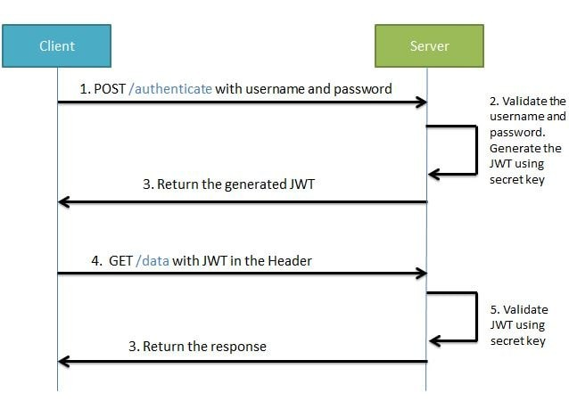

Process

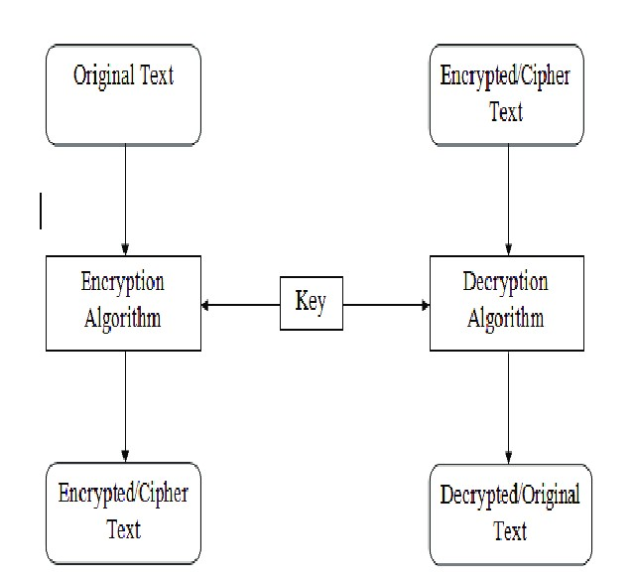

Encryption Process

Step 1- Taking Original Text.

Step 2- Apply encryption Algorithm with “Private key.”

Step 3- Taking the encrypted text.

Step 4- Save encrypted data and database.

Decryption Process

Step 1- From the database, take the encrypted text.

Step 2- Applying the decryption algorithm “Private Key.”

Step 3- Getting the original text.

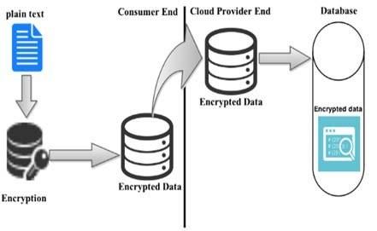

Implementation

In Envision NEXT we use this one to start with JWT, basically, all the steps would be:

- Client send a login request with username and password to server
- Server receive the username and password, authenticate the user
- If authentication is successful, then the server creates a JWT token called accessToken that stores user public info and sends it back to the client.
- Client receives the accessToken, from now on, client sends any request to server, client just attach the accessToken with request.
- Server receives a request, authenticates the JWT token, and continues processing the request, and then returns the result to the client.

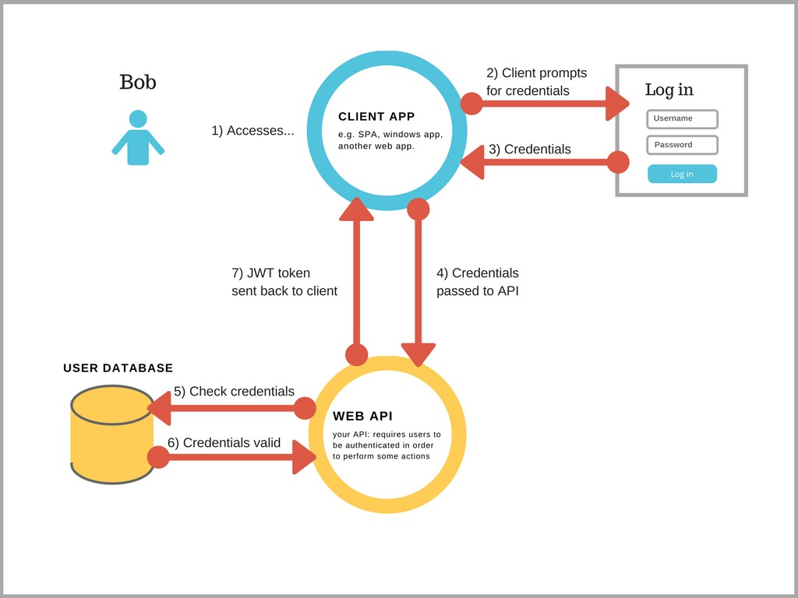

Pictorial/ Visual
Data at rest- When the data at rest it will fully encrypted.

Data at travels- The data is decrypted but the user when try to access this they have to provide JWT authentication.

